Cloud SQL for MySQL: Qwik Start
30 minutes1 Credit

Rate Lab

GSP151

Overview
In this lab you will learn how to create and connect to a Google Cloud SQL MySQL instance and perform basic SQL operations using the Google Cloud Platform Console and the mysql client.

Setup and Requirements

Qwiklabs setup

Before you click the Start Lab button
Read these instructions. Labs are timed and you cannot pause them. The timer, which starts when you click Start Lab, shows how long Cloud resources will be made available to you.
This Qwiklabs hands-on lab lets you do the lab activities yourself in a real cloud environment, not in a simulation or demo environment. It does so by giving you new, temporary credentials that you use to sign in and access the Google Cloud Platform for the duration of the lab.

What you need
To complete this lab, you need:
- Access to a standard internet browser (Chrome browser recommended).
- Time to complete the lab.
Note: If you already have your own personal GCP account or project, do not use it for this lab.

How to start your lab and sign in to the Console
- Click the Start Lab button. If you need to pay for the lab, a pop-up opens for you to select your payment method. On the left is a panel populated with the temporary credentials that you must use for this lab.
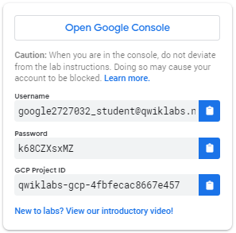
- Copy the username, and then click Open Google Console. The lab spins up resources, and then opens another tab that shows the Choose an account page.
Tip: Open the tabs in separate windows, side-by-side.
- On the Choose an account page, click Use Another Account.
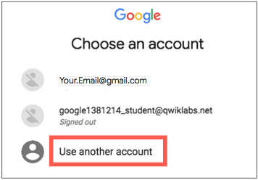
- The Sign in page opens. Paste the username that you copied from the Connection Details panel. Then copy and paste the password.
Important: You must use the credentials from the Connection Details panel. Do not use your Qwiklabs credentials. If you have your own GCP account, do not use it for this lab (avoids incurring charges).
- Click through the subsequent pages:
  - Accept the terms and conditions.
  - Do not add recovery options or two-factor authentication (because this is a temporary account).
  - Do not sign up for free trials.
After a few moments, the GCP console opens in this tab.
Note: You can view the menu with a list of GCP Products and Services by clicking the Navigation menu at the top-left, next to “Google Cloud Platform”. 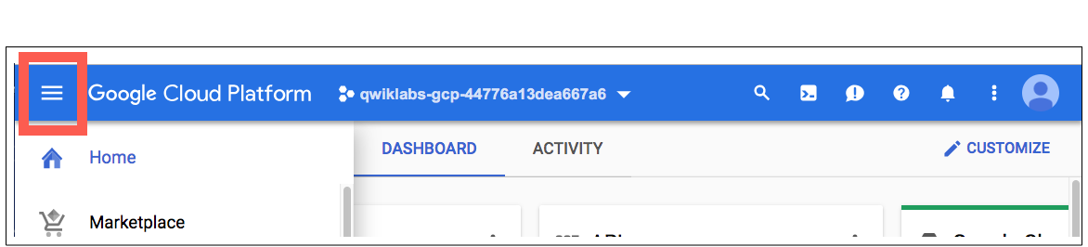

Create a Cloud SQL instance
Click on the menu icon in the top left of the screen to see the Navigation menu.

In the left menu of the Console, click on SQL.
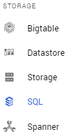
Click Create Instance.
Create your instance with the following settings:
- Click MySQL, then Next.
- Click Choose Second Generation.
- Enter myinstance for Instance ID.
- Enter a password for the root user. Save the password, you'll need it in the next section.
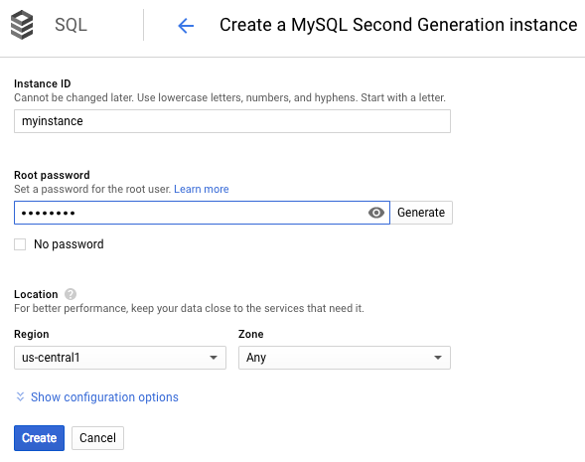
Use the default values for the other fields.
Click Create.
After a few minutes your instance is created and you can continue to the next section. If it seems to be taking a long time, refresh your browser.

Test Completed Task
Click Check my progress to verify your performed task. If you have successfully created Cloud SQL instance, you will see an assessment score.
Create a Cloud SQL instance
Check my progress

Test your Understanding
Below are multiple choice questions to reinforce your understanding of this lab's concepts. Answer them to the best of your abilities.
Instance ID is used to uniquely identify your instance within the project.
True

False

Connect to your instance using the mysql client in the Cloud Shell
In the Google Cloud Platform Console, click the Cloud Shell icon in the upper right corner.

Then click "Start Cloud Shell".
At the Cloud Shell prompt, connect to your Cloud SQL instance by running:
gcloud sql connect myinstance --user=root
Enter your root password when prompted. Note: The cursor will not move.
Press Enter when you're done typing.
You should now see the mysql prompt.

Create a database and upload data
Create a SQL database on your Cloud SQL instance:
CREATE DATABASE guestbook;

Test Completed Task
Click Check my progress to verify your performed task. If you have successfully created custom database on Cloud SQL instance, you will see an assessment score.
Create a database.
Check my progress
Insert sample data into the guestbook database:
USE guestbook;
CREATE TABLE entries (guestName VARCHAR(255), content VARCHAR(255),
entryID INT NOT NULL AUTO_INCREMENT, PRIMARY KEY(entryID));
INSERT INTO entries (guestName, content) values ("first guest", "I got here!");
INSERT INTO entries (guestName, content) values ("second guest", "Me too!");
Retrieve the data:
SELECT * FROM entries;
You should now see:
+--------------+-------------------+---------+
| guestName | content | entryID |
+--------------+-------------------+---------+
| first guest | I got here! | 1 |
| second guest | Me too! | 2 |
+--------------+-------------------+---------+
2 rows in set (0.00 sec)
mysql>
You have created a Google Cloud SQL MySQL instance and connect to it.

Congratulations!

